**How to check Order Version number (SUPP Version)**

Requirement: EFMS GUI

SPP Team engage EFMS Team to check SUPP Version for particular Order# in Workflow

Example: Order # 169668524

**EFMS GUI** [**URL :-**](URL:-)

[**http://efmsms.it.att.com:8008/MS**](http://efmsms.it.att.com:8008/MS)

1. How to open Order in EFMS GUI
2. Go to Order / Sub Order column on the left side of GUI

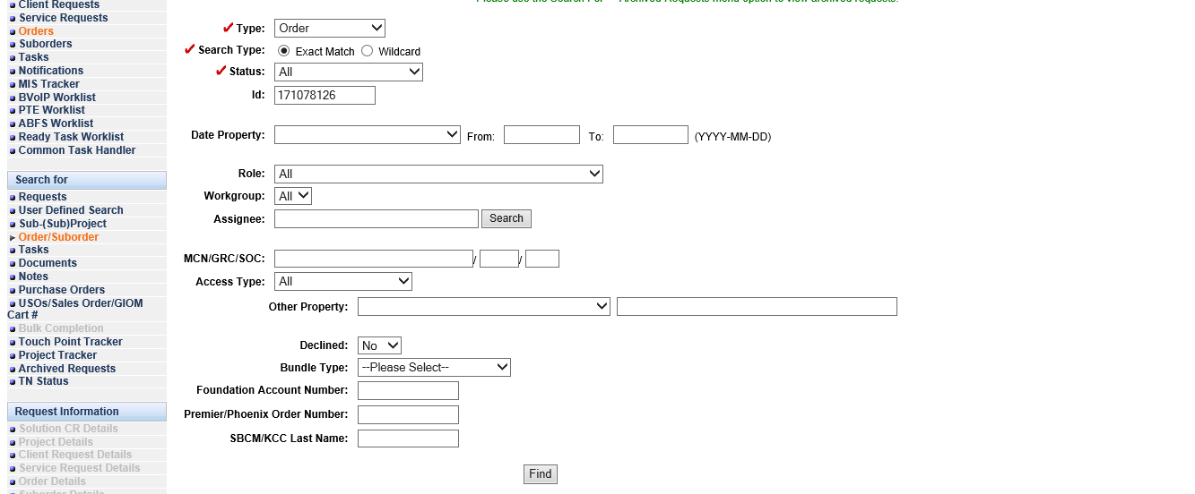

1. Fill the Required data in GUI –
2. Order Type and Order ID:

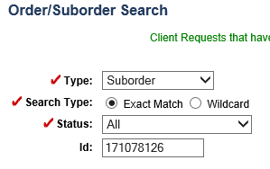

1. Click on Find Button to Open the Order in GUI

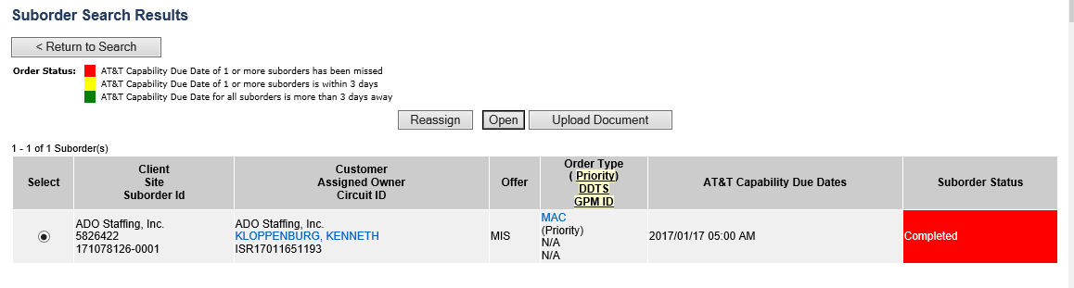

1. By Selecting Tab Activity logs Order Details page
2. We can get Activity Logs in workflow for specific Order

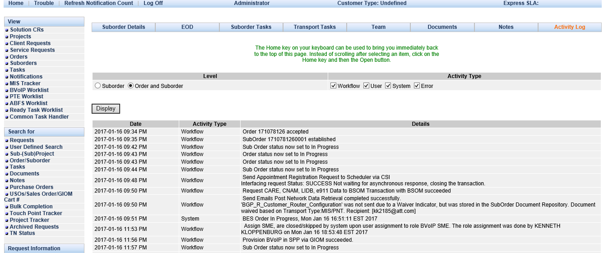

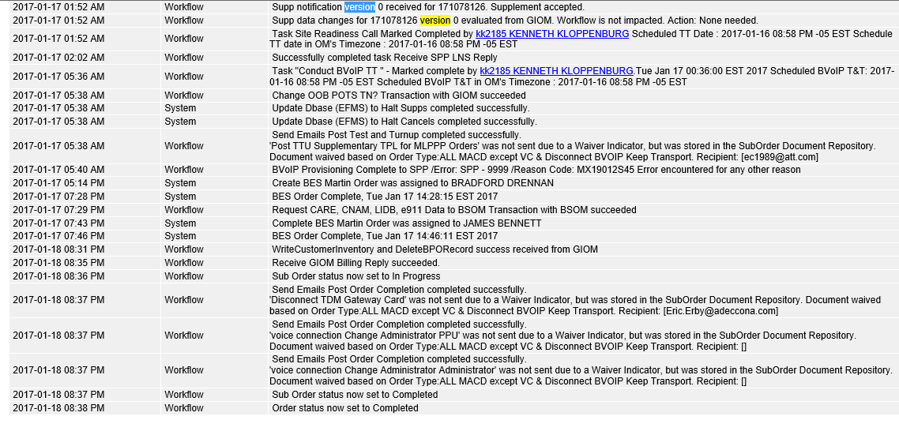

We can search for SUPP Version for particular Order in EFMS

To search the sup version in EFMS,use the below query:

--GIOM (order_version_number/Supp version number)

Select last_updated_date,usrp_order_number, order_version_number, last_supp_process_version, spp_transaction_counter from ms_order where usrp_order_number in('172367242');



In this case Sup Version is 1.